Phase 1: Branding & Business Setup
Business Name: AIspire Studio
Tagline: Inspiring Brands, Instantly
Brand Story:
AIspire Studio exists to make professional branding simple, fast, and inspiring for startups and small businesses. We believe that every brand has a unique story, and with the power of AI, we transform ideas into compelling visuals, engaging social media content, and persuasive marketing copy. From futuristic logos to complete digital branding solutions, AIspire Studio helps startups stand out, attract customers, and grow their business all without the usual delays or high costs. Our mission is to empower entrepreneurs to focus on what they do best, while we bring their brand vision to life.
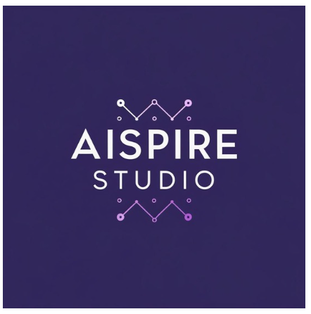
Phase 2: AI-Generated Design & Marketing Content
Step 1: Social Media Content
ChatGPT Prompt for Social Media Posts:
Generate five engaging social media post ideas that promote AI-powered branding services for AIspire Studio. Each post should include a catchy headline, short caption, and a call-to-action encouraging startups to try AI-driven branding.
Example Output:
- Post 1:
  - Headline: “Brand Smarter, Not Harder!”
  - Caption: “AIspire Studio turns your ideas into sleek, AI-powered branding in minutes. Ready to stand out?”
  - CTA: “Get your brand today!”
- Post 2:
  - Headline: “From Vision to Logo in Seconds”
  - Caption: “Watch your startup’s vision come alive with AI-driven logos and visuals.”
  - CTA: “Try AIspire Studio now!”
- Post 3:
  - Headline: “AI Branding for the Modern Startup”
  - Caption: “Fast, creative, and professional branding — powered by AI.”
  - CTA: “Launch your brand instantly!”
- Post 4:
  - Headline: “Stand Out in the Digital Crowd”
  - Caption: “AIspire Studio crafts branding that gets noticed and remembered.”
  - CTA: “Book your AI branding session today!”
- Post 5:
  - Headline: “Branding Made Simple & Smart”
  - Caption: “No delays, no stress — just AI-powered creativity at your fingertips.”
  - CTA: “Start your AI brand journey now!”
Step 2: Canva Magic Media Prompt for Social Media Post Image:
Generate an AI image of a vibrant social media post for AIspire Studio showcasing the power of AI-driven branding for startups. Include futuristic colors (blues, purples, gradients), sleek design elements, and icons representing logos, creativity, and technology. The image should feel modern, energetic, and professional.
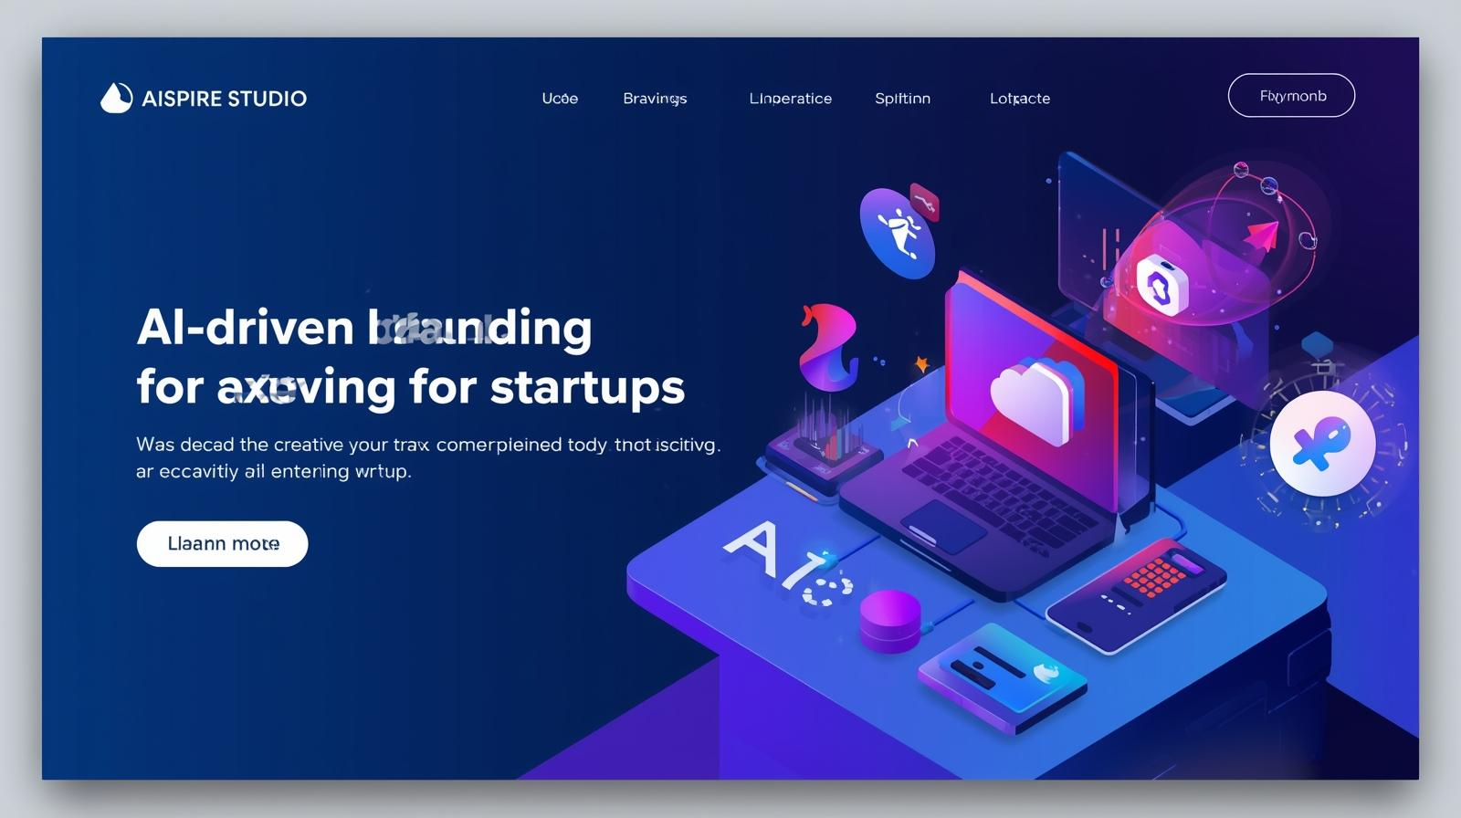
Step 3: Marketing Copy
ChatGPT Prompt for Blog Post / Ads / Product Descriptions:
Write an AI-generated blog post explaining why startups should use AI-powered branding services from AIspire Studio. Include benefits such as fast design, professional visuals, affordability, and creativity. Make it engaging, persuasive, and easy to read for entrepreneurs.
- Ad (Short & Persuasive)
Transform your startup’s identity in minutes! AIspire Studio creates stunning logos, social media visuals, and branding all powered by AI. Get started today!
- Blog Post (Engaging Long-Form)
In the fast-paced startup world, first impressions matter more than ever. A strong, professional brand can make the difference between getting noticed and being overlooked. But traditional branding can be time-consuming and expensive a luxury many startups can’t afford. That’s where AIspire Studio comes in. By leveraging the power of AI, we create logos, social media content, and marketing materials in minutes, helping startups establish a memorable presence quickly and affordably. Our AI-driven approach ensures that each brand we craft is visually striking and tailored to the unique vision of every client. From sleek, futuristic logos to cohesive marketing campaigns, AIspire Studio empowers entrepreneurs to focus on growing their business while we bring their brand to life. With AIspire Studio, building a brand that stands out has never been easier.
- Product Description (Service Offering)
AIspire Studio offers AI-powered branding services designed for startups and small businesses. Our platform delivers professional logos, social media graphics, and marketing materials in minutes. Fast, creative, and affordable, AIspire Studio helps your business establish a strong, memorable brand presence without the traditional time or cost. Experience intelligent branding that works as hard as you do.
Phase 3: Client Outreach & Monetization

Step 1: Strategies for Selling Branding Assets
Here’s is my approach:
1. Offer Package Deals
- Starter Package: Logo + basic social media kit
- Growth Package: Logo + social media graphics + 1 marketing copy
- Premium Package: Full branding kit with logo, social media visuals, website mockup, and multiple marketing materials
2. Tiered Pricing
- Affordable rates for startups
- Premium rates for growing businesses needing comprehensive branding
3. Highlight AI Advantages
- Fast turnaround: Branding created in minutes instead of weeks
- Cost-effective: Lower than traditional design agencies
- Creative & professional: AI ensures visually appealing and modern designs
4. Showcase Portfolio / Examples
- Include sample logos, social media posts, and marketing copy from AIspire Studio
- Build client trust and demonstrate your capabilities
5. Outreach Channels
- Email Marketing: Personalized emails to potential clients
- LinkedIn Outreach: Connect with startups and small business owners
- Social media: Share sample work and testimonials to attract clients

Step 2: Sales Pitch / Outreach Email
ChatGPT Prompt (for your record):
"Write a persuasive email to a potential client explaining how AI-generated branding can help elevate their business presence. Make it professional, concise, and engaging for startups."
Example Email:
Subject: Elevate Your Brand Instantly with AIspire Studio
Hi Lucy,
I hope this message finds you well! I’m reaching out to introduce AIspire Studio, a digital branding agency powered by AI. We help startups like yours create professional logos, social media visuals, and marketing content all in minutes.
With AIspire Studio, you can launch a visually striking and memorable brand without the traditional delays or high costs. Our AI-driven approach ensures your brand stands out and attracts your target audience effectively.
I’d love to show you how we can elevate your brand. Are you available for a quick call or demo this week?
Best regards,
Diana Kemunto.
AIspire Studio
Step 3: Design a Canva pitch deck to attract clients for your AI-powered branding service.

Canva Pitch Deck Prompt
"Design a clean and compelling presentation slide for AIspire Studio, a digital branding agency powered by AI.
The slide should include:
- Agency name and tagline: 'AIspire Studio – Inspiring Brands, Instantly'
- Services offered: logos, social media content, marketing copy
- Key benefits: fast, affordable, professional, AI-powered creativity
- A visual example of AI-generated branding (like a logo or social media mockup)
- A clear call to action for potential clients
Use a sleek, futuristic style with gradient blues and purples, modern typography, and AI-inspired visual elements like digital nodes or abstract tech patterns. Make it professional, startup-friendly, and visually engaging."

